Test task:

Create a mini game using Pixi (using Typescript would be a huge plus):

Mandatory tasks:

1. Create a deck of cards (5) face down. Each card should be placed with small offset (so that we see the quantity of cards).
2. Create ‘Reveal’ button.
3. On click on the button -> the top card flips face up and disappears after 1 second
4. Clicking on ‘Reveal’ button again will reveal the next card
5. Cards deck should be a separate component with public method ‘revealNext’, which should be used to reveal the card

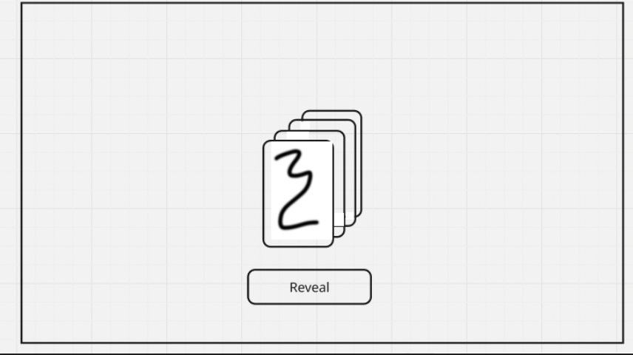

Bonus tasks(not necessary, but the more feature from this list will be implemented the better):

1. Implement flip animation
2. Implement fade out card animation (tween alpha from 1 to 0)
3. Add any sound effect (e.g. on button click or on card flip)

Notes:

Assets/art doesn’t matter, you can use anything downloaded from the internet, generated or created by yourself

Acceptance criteria:

1. Provide zip with source code or a link to github/gitlab/bitbucket
2. Provide instructions on how to build/run the game